SIMATS ENGINEERING

ASSESSMENT TOOL 1

COURSE NAME: Artificial Intelligence
COURSE CODE: CSA17

COURSE OUTCOME COVERED
CO5: Design AI-based systems using PySpark, RDD operations, and intelligent agent architectures, using scalable systems and integrate components in distributed AI applications. (BTL 5)

Assessment Tool Weightage: 50%

Duration : 1 Hour
Annexure A
Design Task

Code of Conduct:
I Pallavi G (192311208) certify that this submission is my original work and that I have adhered to the guidelines specified for this assessment.
I understand that any violation of academic integrity rules will result in disciplinary action.

Signature of the student: Pallavi

Design Task
Edge AI System for Industrial Quality Control
Design an Edge AI system integrated with a PySpark-based backend to inspect products on a high-speed manufacturing line using RDD operations for batch analysis of historical defect data. Explain how distributed data processing supports large-scale model retraining, and describe how intelligent agents at the edge collaborate with the central system to detect defects in real time and adapt inspection thresholds as production conditions change.
ANSWER
Edge AI System for Industrial Quality Control

1. Problem Understanding & Requirement Analysis
A high-speed manufacturing line generates a continuous stream of visual, dimensional, and sensor-based inspection data that must be analysed in real time to detect defective products, while historical defect records must be processed in bulk to retrain and improve detection models. The core requirements are therefore twofold: (a) low-latency, on-device inference at the edge so that defective items can be rejected within the cycle time of the production line, and (b) scalable, distributed batch processing in the cloud/data-centre tier so that terabytes of accumulated defect images, sensor logs, and inspection metadata can be used to retrain models periodically. The system must also tolerate node failures, handle variable production speeds, and allow inspection thresholds to be adapted dynamically as raw-material quality, lighting conditions, or machine wear change over time. Key constraints include network bandwidth between the factory floor and the central cluster, real-time response requirements at the edge, and the need for traceability and auditability of every quality decision.
2. System Architecture Design
The proposed architecture follows a two-tier Edge-Cloud design, illustrated below. At the edge tier, cameras and sensors mounted along the production line feed lightweight CNN-based inference agents deployed on edge devices (e.g., NVIDIA Jetson or industrial PCs) placed close to each inspection station. These agents perform immediate defect classification and communicate decisions to local actuators (reject arms) with millisecond latency. All inspection events, feature vectors, and flagged defect images are simultaneously streamed to a central data-centre tier through a message broker (Kafka) into Spark Structured Streaming, and are also persisted in a distributed data lake (HDFS/S3) for batch analysis. A PySpark cluster performs RDD-based batch processing over historical defect data for feature engineering and periodic model retraining through Spark MLlib. A Multi-Agent Coordination Layer sits between the edge agents and the central orchestrator agent, exchanging threshold updates, defect alerts, and consensus signals, while a quality-control dashboard gives human operators visibility and override capability.
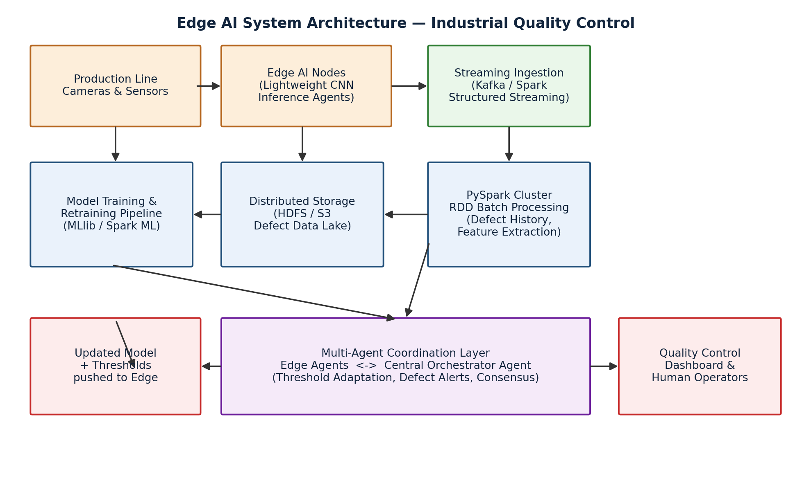
Figure 1: Edge–Cloud Architecture of the Edge AI Quality Control System
3. Use of PySpark & RDD Operations
Historical inspection logs (image feature vectors, sensor readings, timestamps, station IDs, and defect labels) are loaded into Spark as RDDs partitioned across the cluster, enabling parallel processing across worker nodes. Typical RDD transformations and actions used in this pipeline include:
raw_rdd = sc.textFile("hdfs:///defects/logs/*.json")
parsed_rdd = raw_rdd.map(lambda x: parse_json(x))
clean_rdd = parsed_rdd.filter(lambda r: r["sensor_ok"] == True)
featured_rdd = clean_rdd.map(lambda r: extract_features(r))
by_station_rdd = featured_rdd.map(lambda r: (r["station_id"], r))
grouped_rdd = by_station_rdd.groupByKey()
defect_counts = clean_rdd.map(lambda r: (r["defect_type"], 1)) \
.reduceByKey(lambda a, b: a + b)
sample_for_training = featured_rdd.sample(False, 0.3)
training_df = sample_for_training.toDF() # handed to Spark MLlib
map() is used for parsing raw JSON logs and extracting per-image feature vectors in parallel; filter() removes corrupted or incomplete sensor readings; groupByKey()/reduceByKey() aggregate defects by station or defect type to identify recurring failure patterns; and sample() draws balanced training subsets across defect classes. Because RDDs are lazily evaluated and lineage-tracked, the cluster can recompute lost partitions automatically on node failure, giving the pipeline fault tolerance without checkpointing every stage. The resulting RDDs are converted to DataFrames only at the final stage before being fed into Spark MLlib for model training, combining RDD-level flexibility for custom feature engineering with the optimisation benefits of the DataFrame API for training.

4. Intelligent Agent Integration
4.1 Edge Inspection Agents
Each inspection station hosts an autonomous edge agent responsible for capturing sensor/image data, running local CNN inference, comparing the confidence score against the current defect threshold, and triggering a reject/accept decision. These agents operate independently to guarantee real-time response even if network connectivity to the central cluster is temporarily lost, storing decisions locally and forwarding them once connectivity is restored (store-and-forward pattern).
4.2 Central Orchestrator Agent
A central coordination agent, running alongside the PySpark cluster, aggregates defect statistics from all stations, detects drift in defect rates or feature distributions, and decides when a threshold adjustment or a full model retraining cycle is required. It also resolves conflicts when multiple edge agents report ambiguous readings for the same batch of products.
4.3 Collaboration & Adaptation
The two agent types communicate through a lightweight publish/subscribe protocol: edge agents publish inspection outcomes and confidence scores, and the orchestrator agent publishes updated model weights and revised threshold values whenever retraining completes or production conditions shift (for example, a new raw-material batch causing a change in surface texture). This closed feedback loop allows the system to self-adapt: if the false-reject rate at a station rises, the orchestrator can lower the confidence threshold for that station specifically, rather than applying a blanket change across the entire line.
5. Scalability & Distributed Computing Design
Scalability is achieved at both tiers. At the edge, additional inspection stations can be added independently since each edge agent is self-contained and only needs a network link to the broker; there is no central bottleneck for real-time decisions. At the cloud tier, the PySpark cluster scales horizontally by adding worker nodes, and RDD partitioning automatically redistributes the workload across the available executors. Kafka partitions allow the streaming ingestion layer to scale with the number of production lines. Fault tolerance is provided through RDD lineage-based recomputation in Spark, replicated storage in HDFS/S3, and the store-and-forward buffering at edge agents, so that a failure of any single node — edge device, streaming broker, or Spark executor — does not halt production or lose inspection data.
6. Data Flow & Processing Pipeline
The data flow proceeds in two parallel paths. The real-time path begins at the camera/sensor, passes through the edge inference agent, and results in an immediate accept/reject actuation, with the same event asynchronously streamed to Kafka for logging. The batch path periodically pulls accumulated logs from the data lake into PySpark as RDDs, applies the transformation pipeline described in Section 3, aggregates defect statistics, retrains the model using Spark MLlib, and pushes the updated model and thresholds back down to the edge agents through the coordination layer. This dual-path design decouples the millisecond-scale inspection decision from the hour/day-scale model-improvement cycle, ensuring that neither path blocks the other.
7. Innovation & Creativity
The design's key innovation is station-specific adaptive thresholding driven by continuous feedback between edge and cloud agents, rather than a single static model deployed uniformly across the line. Combining lightweight edge inference for latency-critical decisions with RDD-based distributed batch retraining for accuracy improvement allows the system to be both fast and continuously self-improving. The store-and-forward buffering at the edge, together with lineage-based fault recovery in Spark, gives the platform resilience against both network and compute-node failures, which is critical in a 24/7 industrial environment.
8. Conclusion
This Edge AI quality-control platform combines low-latency edge inference, PySpark/RDD-based distributed batch analytics, and a two-tier intelligent-agent architecture to deliver real-time defect detection that continuously improves through large-scale distributed retraining. The design satisfies the requirements of scalability, fault tolerance, and adaptive, agent-driven decision-making demanded by a modern high-speed manufacturing environment.

Rubrics for Calculation
Weightage of each evaluation criterion:
Problem Understanding & Requirement Analysis | System Architecture Design | Use of PySpark & RDD Operations | Intelligent Agent Integration | Scalability & Distributed Computing Design | Data Flow & Processing Pipeline | Innovation & Creativity | Clarity, Presentation & Documentation
10% | 20% | 15% | 15% | 10% | 10% | 10% | 10%

Detailed performance-level descriptors for each criterion:
Criteria | Excellent (5) | Good (4) | Average (3) | Poor (2)
Problem Understanding & Requirement Analysis | Clearly defines problem, objectives, and constraints | Mostly clear with minor gaps | Basic understanding | Unclear or incorrect
System Architecture Design | Complete, scalable, well-structured architecture with diagrams | Good design with minor issues | Basic design, lacks detail | Poor/incomplete
Use of PySpark & RDD Operations | Efficient and correct use of RDD transformations/actions | Mostly correct usage | Limited or partial use | Incorrect/missing
Intelligent Agent Integration | Strong integration with clear agent roles and logic | Good integration | Basic integration | Poor/no integration
Scalability & Distributed Computing Design | Clearly addresses scalability, fault tolerance, parallelism | Covers most aspects | Limited consideration | Not addressed
Data Flow & Processing Pipeline | Clear, logical, and well-defined data flow | Mostly clear | Some gaps | Poorly defined
Innovation & Creativity | Highly innovative, realistic, and impactful solution | Some innovation | Basic idea | No originality
Clarity, Presentation & Documentation | Very clear, neat diagrams, well-organized report | Mostly clear | Somewhat organized | Poor presentation

